Web Technology
Practical File


Department of Electronics and Communication(2022-23)
NETAJI SUBHAS UNIVERSITY OF TECHNOLOGY NEW DELHI-110078

Submitted To: Submitted By:
Mahima Yadav Name: Vaibhav Varshney
Roll No: 2019UEC2526

Index

S.No | Topic | Page No | Signature
1. | Create a web page using HTML and CSS file.
2. | Apply javascript to validate forms
3. | Create a web page to show application of form controls.
4. | Write a program and calculate the values of different web IR performance metrics.
5. | Develop a client-server application and show the interaction using 2-way communication/handshaking.
6. | For the application made in Q3, develop database and write queries using MongoDB for outputting the values of different fields.
7. | For the application made in Q3, develop database and write queries using MySQL and NoSQL.
8. | Form groups of 2-3 students and create a web site using any front end and back end web technology tool (HTML, CSS, JavaScript, DHTML, XML and PHP).

Experiment 1

Aim : Create a web page using HTML and CSS file.
Solution:
HTML code:
<!DOCTYPE html>
<html>
<head>
<meta charset="UTF-8" />
<meta name="viewport" content="width=device-width, initial-scale=1.0" />
<link
rel="stylesheet"
href="https://maxcdn.bootstrapcdn.com/bootstrap/4.0.0/css/bootstrap.min.css"
/>
<link rel="stylesheet" href="style.css" />
<title>Student Detail Form</title>
</head>

<body>
<main>
<section id="about" class="about">
<div class="container">
<div class="row">
<div class="col-lg-12">
<h1 class="text-center">Student Detail Form</h1>
</div>
</div>
</div>
</section>

<section id="formSection" class="formSection">
<form
name="myForm"
action="/myaction.php"
enctype="multipart/form-data"
onsubmit="return validateForm()"
method="post"
>
<div class="container">
<div class="row">
<label class="col-4" for="fName">First Name</label>
<input class="col-4" type="text" id="fName" name="fName" />
</div>

<div class="row">
<label class="col-4" for="lName">Last Name</label>
<input class="col-4" type="text" id="lName" name="lName" />

</div>
<div class="row">
<label class="col-4" for="rNo">Roll Number</label>
<input class="col-4" type="text" id="rNo" name="rNo" />
</div>

<div class="row">
<label class="col-4" for="mNo">Mobile Number</label>
<input class="col-4" type="text" id="mNo" name="mNo" />
</div>

<div class="row">
<label class="col-4" for="eMail">Email</label>
<input class="col-4" type="text" id="eMail" name="eMail" />
</div>

<div class="row">
<label class="col-4" for="branch">Branch</label>
<select
name="branch"
class="form-select"
aria-label="Default select example"
>
<option value="" selected>Choose...</option>
<option value="COE">COE</option>
<option value="IT">IT</option>
<option value="ECE">ECE</option>
<option value="ME">ME</option>
</select>
</div>
<div class="row">
<label class="col-4" for="gender">Gender</label>

<div class="form-check col-2">
<input
class="form-check-input"
type="radio"
name="flexRadioDefault"
id="flexRadioDefault1"
value="MALE"
checked
/>
<label class="form-check-label" for="flexRadioDefault1">
Male
</label>
</div>
<div class="form-check col-2">
<input
class="form-check-input"
type="radio"
name="flexRadioDefault"
id="flexRadioDefault2"
value="FEMALE"
/>
<label class="form-check-label" for="flexRadioDefault2">
Female
</label>
</div>
</div>
<div class="row">
<label class="col-4" for="birthday">DOB</label><br />
<input
class="col-4"
type="date"
id="birthday"
name="birthday"
/><br /><br />
</div>

<input type="submit" value="Submit" />
</div>
</form>
</section>
</main>
</body>
<script src="main.js"></script>
</html>

CSS code:
body {
font-family: Arial, sans-serif;
background-color: #f0f0f0;
color: #333;
transition: all 0.3s ease;
}
.about {
padding: 60px 0;
}
.row {
margin-bottom: 5px;
}
Result :
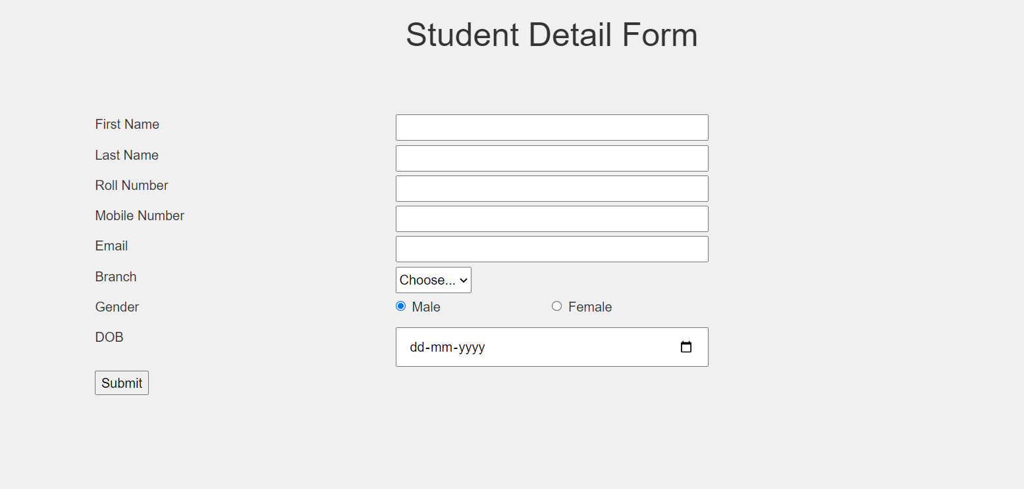

Experiment 2
Aim: Apply javascript to validate forms.
Solution:
JS code:
function validateForm() {
var fName = document.forms["myForm"]["fName"].value;
var lName = document.forms["myForm"]["lName"].value;
var rNo = document.forms["myForm"]["rNo"].value;
var mNo = document.forms["myForm"]["mNo"].value;
var eMail = document.forms["myForm"]["eMail"].value;
var birthday = document.forms["myForm"]["birthday"].value;
var branch = document.forms["myForm"]["branch"].value;
var gender = document.forms["myForm"]["flexRadioDefault"].value;

console.log("fname :", fName);
console.log("lName :", lName);
console.log("rNo :", rNo);
console.log("mNo :", mNo);
console.log("eMail :", eMail);
console.log("birthday :", birthday);
console.log("branch :", branch);
console.log("gender :", gender);

if (fName.length == 0) alert("First name can not be empty");
else if (lName.length == 0) alert("Last name can not be empty");
else if (rNo.length != 11) alert("Enter valid roll number");
else if (mNo.length != 10) alert("Enter valid 10 digit mobile number");
else if (eMail.search("@") == -1 && eMail.length == 0)
alert("Enter valid email");
else if (branch.length == 0) alert("Select branch");
else if (birthday.length == 0) alert("Enter DOB");
return false;
}
Result:
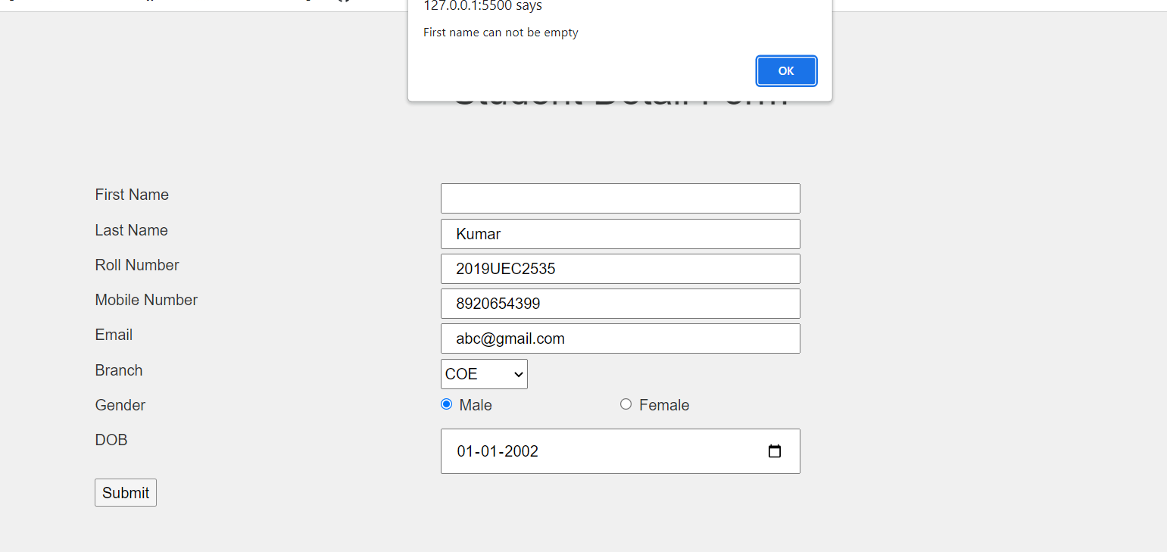

Experiment 3
Aim : Create a web page to show application of form controls.
Solution:
HTML Code:
<!DOCTYPE html>
<html>
<head>
<meta charset="UTF-8" />
<meta name="viewport" content="width=device-width, initial-scale=1.0" />
<link
rel="stylesheet"
href="https://maxcdn.bootstrapcdn.com/bootstrap/4.0.0/css/bootstrap.min.css"
/>
<link rel="stylesheet" href="style.css" />
<title>Student Detail Form</title>
</head>

<body>
<nav class="navbar navbar-expand-lg navbar-dark bg-primary">
<a class="navbar-brand" href="#">Class App</a>
<button
class="navbar-toggler"
type="button"
data-toggle="collapse"
data-target="#navbarNav"
aria-controls="navbarNav"
aria-expanded="false"
aria-label="Toggle navigation"
>
<span class="navbar-toggler-icon"></span>
</button>
<div class="collapse navbar-collapse" id="navbarNav">
<ul class="navbar-nav">
<li class="nav-item">
<a class="nav-link" href="#about">About</a>
</li>
<li class="nav-item">
<a class="nav-link" href="#skills">Skills</a>
</li>

<li class="nav-item">
<a class="nav-link" href="#contact">Contact</a>
</li>
</ul>
</div>
</nav>
<main>
<section id="about" class="about">
<div class="container">
<div class="row">
<div class="col-lg-12">
<h1 class="text-center">Student Detail Form</h1>
</div>
</div>
</div>
</section>

<section id="formSection" class="formSection">
<form
name="myForm"
action="/myaction.php"
enctype="multipart/form-data"
onsubmit="return validateForm()"
method="post"
>
<div class="container">
<div class="row">
<label class="col-4" for="fName">First Name</label>
<input class="col-4" type="text" id="fName" name="fName" />
</div>

<div class="row">
<label class="col-4" for="lName">Last Name</label>
<input class="col-4" type="text" id="lName" name="lName" />
</div>

<div class="row">
<label class="col-4" for="rNo">Roll Number</label>
<input class="col-4" type="text" id="rNo" name="rNo" />
</div>

<div class="row">
<label class="col-4" for="mNo">Mobile Number</label>
<input class="col-4" type="text" id="mNo" name="mNo" />
</div>

<div class="row">
<label class="col-4" for="eMail">Email</label>
<input class="col-4" type="text" id="eMail" name="eMail" />
</div>

<div class="row">
<label class="col-4" for="branch">Branch</label>
<select
name="branch"
class="form-select"
aria-label="Default select example"
>
<option value="" selected>Choose...</option>
<option value="COE">COE</option>
<option value="IT">IT</option>
<option value="ECE">ECE</option>
<option value="ME">ME</option>
</select>
</div>

<div class="row">
<label class="col-4" for="gender">Gender</label>

<div class="form-check col-2">
<input
class="form-check-input"
type="radio"
name="flexRadioDefault"
id="flexRadioDefault1"
value="MALE"
checked
/>
<label class="form-check-label" for="flexRadioDefault1">
Male
</label>
</div>
<div class="form-check col-2">
<input
class="form-check-input"
type="radio"
name="flexRadioDefault"
id="flexRadioDefault2"
value="FEMALE"
/>
<label class="form-check-label" for="flexRadioDefault2">
Female
</label>
</div>
</div>

<div class="row">
<label class="col-4" for="birthday">DOB</label><br />
<input
class="col-4"
type="date"
id="birthday"
name="birthday"
/><br /><br />
</div>

<div class="row">
<label for="fileInput" class="col-4">Photo</label>
<input
class="form-control col-4"
type="file"
id="fileInput"
name="fileInput"
/>
</div>

<div class="row">
<label class="col-4" for="description">Description</label>
<textarea
class="col-4"
name="description"
id="description"
></textarea>
</div>

<div class="row">
<label class="col-4" for="vehicle">Vehicle</label>
<div class="col-2">
<input
type="checkbox"
id="twoWheeler"
name="twoWheeler"
value="2"
/>
<label for="twoWheeler">2 wheeler</label>
</div>
<div class="col-2">
<input
type="checkbox"
id="fourWheeler"
name="fourWheeler"
value="4"
/>
<label for="fourWheeler">4 wheeler</label>
</div>
</div>
<input type="submit" value="Submit" />
</div>
</form>
</section>
</main>
</body>
<script src="main.js"></script>
</html>

CSS code:
body {
font-family: Arial, sans-serif;
background-color: #f0f0f0;
color: #333;
}

.bg-primary {
background-color: #007bff !important;
}

.navbar {
margin-bottom: 30px;
}

.about {
padding: 60px 0;
}

.skills {
padding: 60px 0;
}
.about {
padding: 60px 0;
}

.skills {
padding: 60px 0;
}

.row {
margin-bottom: 5px;
}

JS code:
function validateForm() {
var fName = document.forms["myForm"]["fName"].value;
var lName = document.forms["myForm"]["lName"].value;
var rNo = document.forms["myForm"]["rNo"].value;
var mNo = document.forms["myForm"]["mNo"].value;
var eMail = document.forms["myForm"]["eMail"].value;
var birthday = document.forms["myForm"]["birthday"].value;
var branch = document.forms["myForm"]["branch"].value;
var gender = document.forms["myForm"]["flexRadioDefault"].value;
var fileInput = document.forms["myForm"]["fileInput"].value;
var description = document.forms["myForm"]["description"].value;
var twoWheeler = document.forms["myForm"]["twoWheeler"].value;
var fourWheeler = document.forms["myForm"]["fourWheeler"].value;

console.log("fname :", fName);
console.log("lName :", lName);
console.log("rNo :", rNo);
console.log("mNo :", mNo);
console.log("eMail :", eMail);
console.log("birthday :", birthday);
console.log("branch :", branch);
console.log("gender :", gender);
console.log("fileInput :", fileInput);
console.log("description :", description);
console.log("twoWheeler :", twoWheeler);
console.log("fourWheeler :", fourWheeler);

if (fName.length == 0) alert("First name can not be empty");
else if (lName.length == 0) alert("Last name can not be empty");
else if (rNo.length != 11) alert("Enter valid roll number");
else if (mNo.length != 10) alert("Enter valid 10 digit mobile number");
else if (eMail.search("@") == -1 && eMail.length == 0)
alert("Enter valid email");
else if (branch.length == 0) alert("Select branch");
else if (birthday.length == 0) alert("Enter DOB");
return false;
}

Result :
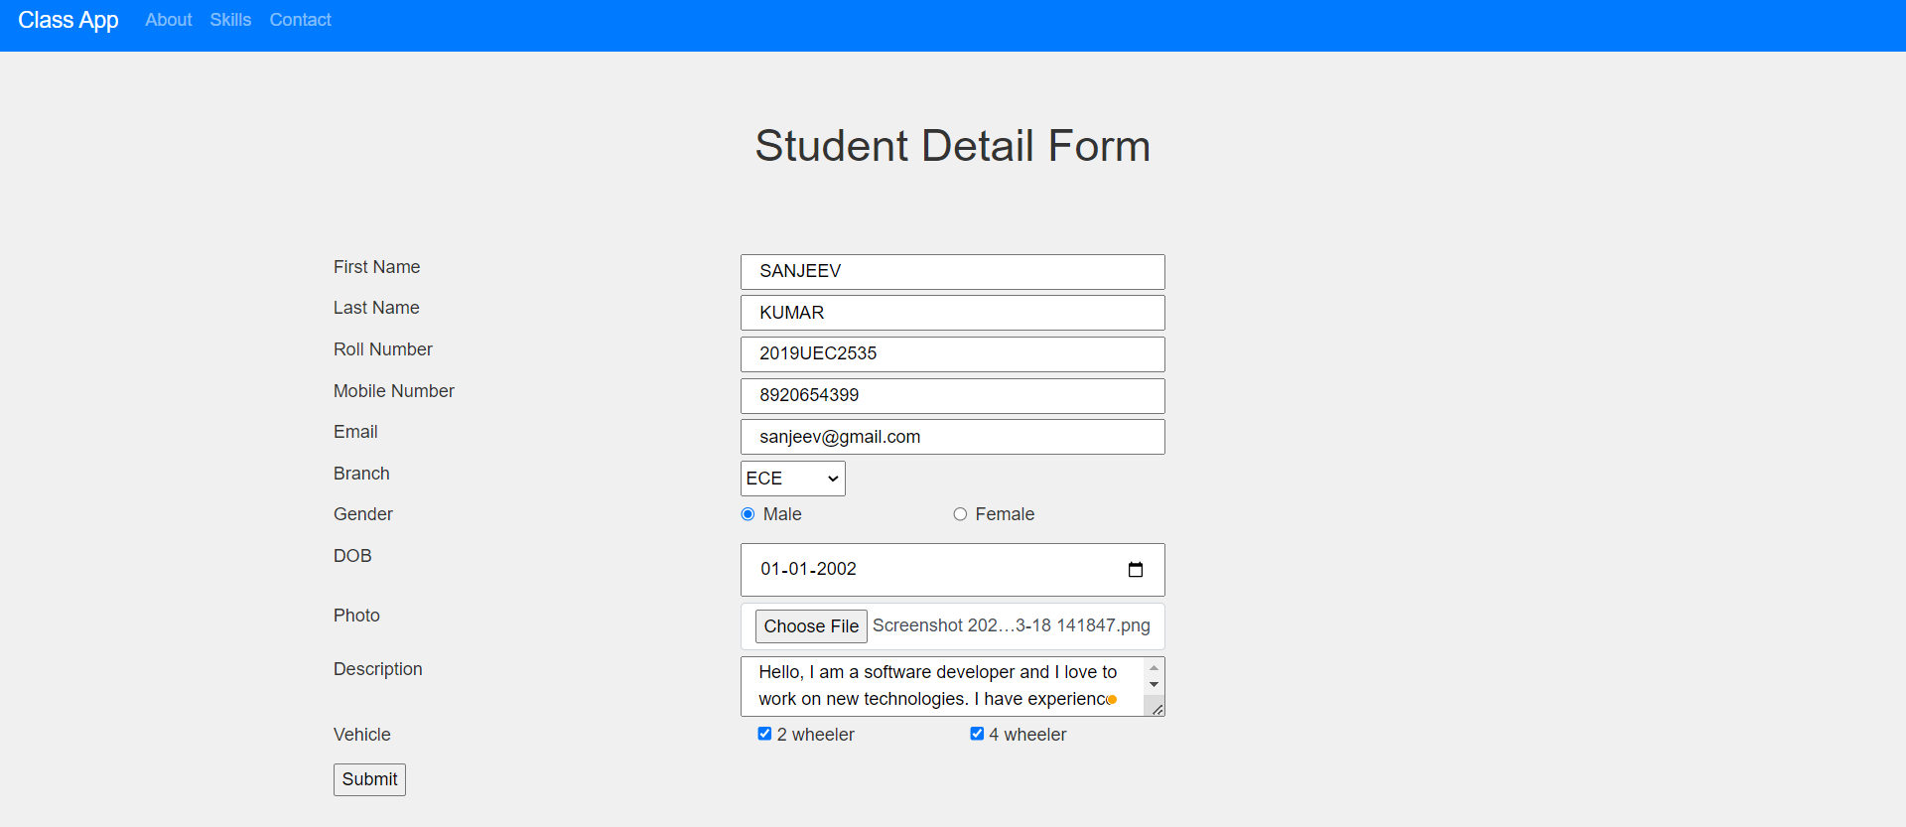

Experiment 4
Aim : Write a program and calculate the values of different web IR performance metrics.
Solution:
C++ code :
#include <bits/stdc++.h>
using namespace std;
int main()
{
float tn,tp,fn,fp;
cout<<"Enter value of true positive :";
cin>>tp;
cout<<"Enter value of true negative :";
cin>>tn;
cout<<"Enter value of false positive :";
cin>>fp;
cout<<"Enter value of false negative :";
cin>>fn;

float precision,recall,accuracy,errorRate,fallout,specificity,fmeasure;
precision = tp/(tp+fp);
recall = tp/(fn+tp) ;
accuracy = (tp+tn)/(tp+tn+fp+fn) ;
errorRate = (fp+fn)/(tp+tn+fp+fn);
fallout = fp/(tn+fp) ;
specificity = tn/(tn+fp);
fmeasure = (2*precision*recall)/(precision+recall);

cout<<"Following are the performance measures :\n";
cout<<"Precision : "<<precision<<"\n";

cout<<"Recall : "<<recall<<"\n";
cout<<"Accuracy : "<<accuracy<<"\n";
cout<<"Error Rate : "<<errorRate<<"\n";
cout<<"Fall Out : "<<fallout<<"\n";
cout<<"Specificity : "<<specificity<<"\n";
cout<<"F-measure : "<<fmeasure<<"\n";

}
Result :
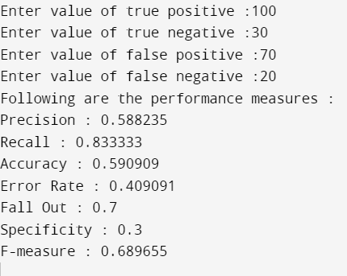

Experiment 5
Aim : Develop a client-server application and show the interaction using 2-way communication/handshaking.
Solution :
JS Code :
const express = require('express')
const app = express()
const port = 5000
const cors = require('cors');
app.use(cors());
app.use(express.json());

app.get('/', (req, res) => {
res.send('Hello World!')
})
app.listen(port, () => {
console.log(`Example app listening on port ${port}`)
})

Result :

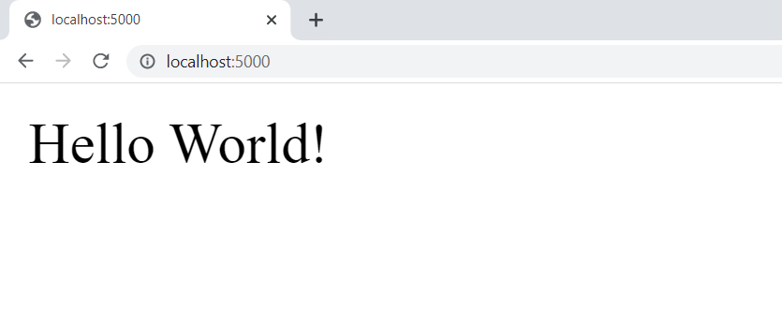

Experiment 6
Aim : For the application made in Q3, develop database and write queries using MongoDB for outputting the values of different fields.
Solution :
Client code :
import logo from "./logo.svg";
import "./App.css";
import axios from "axios";

function App() {
async function submitForm(formData) {
console.log("formData :", formData);
await axios({
method: "post",
url: "http://localhost:5000/",
data: {
formData: formData,
},
})
.then((res) => {
console.log("result :", res.data);
if (res.data) alert("Data saved successfully");
else alert("Error !!!");
})
.catch(() => alert("Server Error!!!"));
}
function validateForm(e) {
// e.preventDefault();
var fName = document.forms["myForm"]["fName"].value;
var lName = document.forms["myForm"]["lName"].value;
var rNo = document.forms["myForm"]["rNo"].value;
var mNo = document.forms["myForm"]["mNo"].value;
var eMail = document.forms["myForm"]["eMail"].value;
var birthday = document.forms["myForm"]["birthday"].value;
var branch = document.forms["myForm"]["branch"].value;
var gender = document.forms["myForm"]["flexRadioDefault"].value;
var fileInput = document.forms["myForm"]["fileInput"].value;
var description = document.forms["myForm"]["description"].value;

let formData = {
fName,
lName,
rNo,
mNo,
eMail,
birthday,
branch,
gender,
fileInput,
description,
};

console.log("fname :", fName);
console.log("lName :", lName);
console.log("rNo :", rNo);
console.log("mNo :", mNo);
console.log("eMail :", eMail);
console.log("birthday :", birthday);
console.log("branch :", branch);
console.log("gender :", gender);
console.log("fileInput :", fileInput);
console.log("description :", description);

if (fName.length == 0) alert("First name can not be empty");
else if (lName.length == 0) alert("Last name can not be empty");
else if (rNo.length != 11) alert("Enter valid roll number");
else if (mNo.length != 10) alert("Enter valid 10 digit mobile number");
else if (eMail.search("@") == -1 && eMail.length == 0)
alert("Enter valid email");
else if (branch.length == 0) alert("Select branch");
else if (birthday.length == 0) alert("Enter DOB");
else {
submitForm(formData);
}
return true;
}

return (
<div className="App">
<div>
<nav className="navbar navbar-expand-lg navbar-dark bg-primary">
<a className="navbar-brand" href="#">
Class App
</a>
<button
className="navbar-toggler"
type="button"
data-toggle="collapse"
data-target="#navbarNav"
aria-controls="navbarNav"
aria-expanded="false"
aria-label="Toggle navigation"
>
<span className="navbar-toggler-icon" />
</button>
<div className="collapse navbar-collapse" id="navbarNav">
<ul className="navbar-nav">
<li className="nav-item">
<a className="nav-link" href="#about">
About
</a>
</li>
<li className="nav-item">
<a className="nav-link" href="#skills">
Skills
</a>
</li>
<li className="nav-item">
<a className="nav-link" href="#contact">
Contact
</a>
</li>
</ul>
</div>
</nav>
<main>
<section id="about" className="about">
<div className="container">
<div className="row">
<div className="col-lg-12">
<h1 className="text-center">Student Detail Form</h1>
</div>
</div>
</div>
</section>
<section id="formSection" className="formSection">
<form name="myForm" onSubmit={validateForm}>
<div className="container">
<div className="row">
<label className="col-4" htmlFor="fName">
First Name
</label>
<input
className="col-4"
type="text"
id="fName"
name="fName"
/>
</div>
<div className="row">
<label className="col-4" htmlFor="lName">
Last Name
</label>
<input
className="col-4"
type="text"
id="lName"
name="lName"
/>
</div>
<div className="row">
<label className="col-4" htmlFor="rNo">
Roll Number
</label>
<input className="col-4" type="text" id="rNo" name="rNo" />
</div>
<div className="row">
<label className="col-4" htmlFor="mNo">
Mobile Number
</label>
<input className="col-4" type="text" id="mNo" name="mNo" />
</div>
<div className="row">
<label className="col-4" htmlFor="eMail">
Email
</label>
<input
className="col-4"
type="text"
id="eMail"
name="eMail"
/>
</div>
<div className="row">
<label className="col-4" htmlFor="branch">
Branch
</label>
<select
name="branch"
className="form-select"
aria-label="Default select example"
>
<option value selected>
Choose...
</option>
<option value="COE">COE</option>
<option value="IT">IT</option>
<option value="ECE">ECE</option>
<option value="ME">ME</option>
</select>
</div>
<div className="row">
<label className="col-4" htmlFor="gender">
Gender
</label>
<div className="form-check col-2">
<input
className="form-check-input"
type="radio"
name="flexRadioDefault"
id="flexRadioDefault1"
defaultValue="MALE"
defaultChecked
/>
<label
className="form-check-label"
htmlFor="flexRadioDefault1"
>
Male
</label>
</div>
<div className="form-check col-2">
<input
className="form-check-input"
type="radio"
name="flexRadioDefault"
id="flexRadioDefault2"
defaultValue="FEMALE"
/>
<label
className="form-check-label"
htmlFor="flexRadioDefault2"
>
Female
</label>
</div>
</div>
<div className="row">
<label className="col-4" htmlFor="birthday">
DOB
</label>
<br />
<input
className="col-4"
type="date"
id="birthday"
name="birthday"
/>
<br />
<br />
</div>
<div className="row">
<label htmlFor="fileInput" className="col-4">
Photo
</label>
<input
className="form-control col-4"
type="file"
id="fileInput"
name="fileInput"
/>
</div>
<div className="row">
<label className="col-4" htmlFor="description">
Description
</label>
<textarea
className="col-4"
name="description"
id="description"
defaultValue={""}
/>
</div>

<input type="submit" defaultValue="Submit" />
</div>
</form>
</section>
</main>
</div>
</div>
);
}

export default App;

Server code :
const express = require("express");
const { MongoClient } = require("mongodb");

const app = express();
const port = 5000;
const cors = require("cors");
app.use(cors());
app.use(express.json());

const mongodb_url = "mongodb://localhost:27017";
const client = new MongoClient(mongodb_url);

// Database Name
const dbName = "webTech";

app.get("/", (req, res) => {
res.send("Hello World!");
});
app.post("/", async (req, res) => {
let formData = req.body.formData;
console.log("received data :", formData);
const db = client.db(dbName);
const collection = db.collection("documents");
const insertResult = await collection.insertOne(formData);
console.log("insert result :", insertResult);
res.send(insertResult.acknowledged);
});

app.listen(port, async () => {
console.log(`Example app listening on port ${port}`);

await client.connect();
console.log("Connected successfully to server");
});

Result :
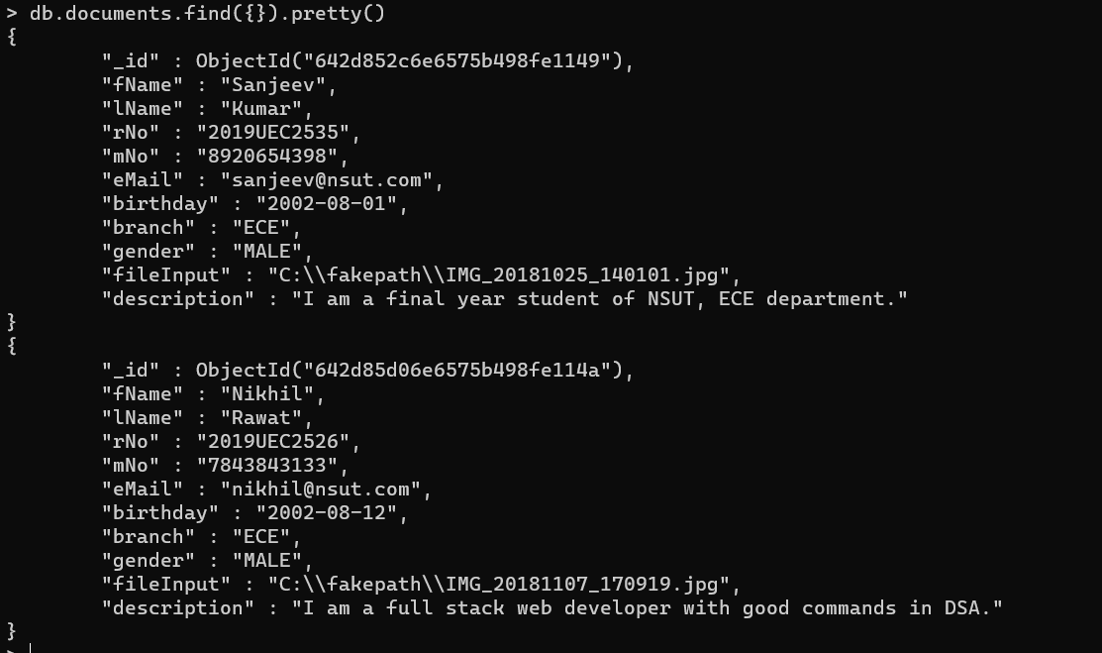

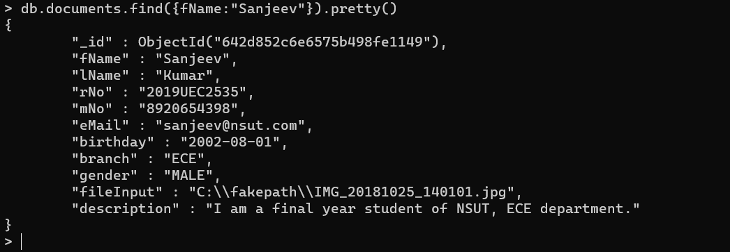

Experiment 7
Aim : For the application made in Q3, develop database and write queries using MySQL.
Solution:
Client code:
import logo from "./logo.svg";
import "./App.css";
import axios from "axios";

function App() {
async function submitForm(formData) {
console.log("formData :", formData);
await axios({
method: "post",
url: "http://localhost:5000/",
data: {
formData: formData,
},
})
.then((res) => {
console.log("result :", res.data);
if (res.data) alert("Data saved successfully");
else alert("Error !!!");
})
.catch(() => alert("Server Error!!!"));
}
function validateForm(e) {
e.preventDefault();
var fName = document.forms["myForm"]["fName"].value;
var lName = document.forms["myForm"]["lName"].value;
var rNo = document.forms["myForm"]["rNo"].value;
var mNo = document.forms["myForm"]["mNo"].value;
var eMail = document.forms["myForm"]["eMail"].value;
var birthday = document.forms["myForm"]["birthday"].value;
var branch = document.forms["myForm"]["branch"].value;
var gender = document.forms["myForm"]["flexRadioDefault"].value;
var fileInput = document.forms["myForm"]["fileInput"].value;
var description = document.forms["myForm"]["description"].value;

let formData = {
fName,
lName,
rNo,
mNo,
eMail,
birthday,
branch,
gender,
fileInput,
description,
};

console.log("fname :", fName);
console.log("lName :", lName);
console.log("rNo :", rNo);
console.log("mNo :", mNo);
console.log("eMail :", eMail);
console.log("birthday :", birthday);
console.log("branch :", branch);
console.log("gender :", gender);
console.log("fileInput :", fileInput);
console.log("description :", description);

if (fName.length == 0) alert("First name can not be empty");
else if (lName.length == 0) alert("Last name can not be empty");
else if (rNo.length != 11) alert("Enter valid roll number");
else if (mNo.length != 10) alert("Enter valid 10 digit mobile number");
else if (eMail.search("@") == -1 && eMail.length == 0)
alert("Enter valid email");
else if (branch.length == 0) alert("Select branch");
else if (birthday.length == 0) alert("Enter DOB");
else {
submitForm(formData);
}
return true;
}

return (
<div className="App">
<div>
<nav className="navbar navbar-expand-lg navbar-dark bg-primary">
<a className="navbar-brand" href="#">
Class App
</a>
<button
className="navbar-toggler"
type="button"
data-toggle="collapse"
data-target="#navbarNav"
aria-controls="navbarNav"
aria-expanded="false"
aria-label="Toggle navigation"
>
<span className="navbar-toggler-icon" />
</button>
<div className="collapse navbar-collapse" id="navbarNav">
<ul className="navbar-nav">
<li className="nav-item">
<a className="nav-link" href="#addPage">
Student Detail Form
</a>
</li>
<li className="nav-item">
<a className="nav-link" href="#searchPage">
Search
</a>
</li>
</ul>
</div>
</nav>
<main>
<section id="about" className="about">
<div className="container">
<div className="row">
<div className="col-lg-12">
<h1 id="addPage" className="text-center">
Student Detail Form
</h1>
</div>
</div>
</div>
</section>
<section id="formSection" className="formSection">
<form name="myForm" onSubmit={validateForm}>
<div className="container">
<div className="row">
<label className="col-4" htmlFor="fName">
First Name
</label>
<input
className="col-4"
type="text"
id="fName"
name="fName"
/>
</div>
<div className="row">
<label className="col-4" htmlFor="lName">
Last Name
</label>
<input
className="col-4"
type="text"
id="lName"
name="lName"
/>
</div>
<div className="row">
<label className="col-4" htmlFor="rNo">
Roll Number
</label>
<input className="col-4" type="text" id="rNo" name="rNo" />
</div>
<div className="row">
<label className="col-4" htmlFor="mNo">
Mobile Number
</label>
<input className="col-4" type="text" id="mNo" name="mNo" />
</div>
<div className="row">
<label className="col-4" htmlFor="eMail">
Email
</label>
<input
className="col-4"
type="text"
id="eMail"
name="eMail"
/>
</div>
<div className="row">
<label className="col-4" htmlFor="branch">
Branch
</label>
<select
name="branch"
className="form-select"
aria-label="Default select example"
>
<option value selected>
Choose...
</option>
<option value="COE">COE</option>
<option value="IT">IT</option>
<option value="ECE">ECE</option>
<option value="ME">ME</option>
</select>
</div>
<div className="row">
<label className="col-4" htmlFor="gender">
Gender
</label>
<div className="form-check col-2">
<input
className="form-check-input"
type="radio"
name="flexRadioDefault"
id="flexRadioDefault1"
defaultValue="MALE"
defaultChecked
/>
<label
className="form-check-label"
htmlFor="flexRadioDefault1"
>
Male
</label>
</div>
<div className="form-check col-2">
<input
className="form-check-input"
type="radio"
name="flexRadioDefault"
id="flexRadioDefault2"
defaultValue="FEMALE"
/>
<label
className="form-check-label"
htmlFor="flexRadioDefault2"
>
Female
</label>
</div>
</div>
<div className="row">
<label className="col-4" htmlFor="birthday">
DOB
</label>
<br />
<input
className="col-4"
type="date"
id="birthday"
name="birthday"
/>
<br />
<br />
</div>

<div className="row">
<label className="col-4" htmlFor="description">
Description
</label>
<textarea
className="col-4"
name="description"
id="description"
defaultValue={""}
/>
</div>

<input type="submit" defaultValue="Submit" />
</div>
</form>
</section>
</main>
</div>
</div>
);
}

export default App;

Server code:
const express = require("express");

const app = express();
const port = 5000;
const cors = require("cors");
app.use(cors());
app.use(express.json());
const sqlite3 = require("sqlite3").verbose();
let db = new sqlite3.Database("studentData.db", (err) => {
if (err) {
console.error(err.message);
} else console.log("Connected to the database");
});
// db.run(
// "CREATE TABLE studentData (fName varchar(20),lName varchar(20),rNo varchar(20),mNo varchar(20),eMail varchar(20),birthday varchar(20),branch varchar(20),gender varchar(10))"
// );
// db.run(`drop table studentData`);
app.get("/", (req, res) => {
res.send("Hello World!");
});

app.post("/", async (req, res) => {
let formData = req.body.formData;
console.log("received data :", formData);
let sql =
"INSERT INTO studentData VALUES(" +
formData.fName +
"," +
formData.lName +
"," +
formData.rNo +
"," +
formData.mNo +
"," +
formData.eMail +
"," +
formData.birthday +
"," +
formData.branch +
"," +
formData.gender +
"," +
formData.fileInput +
"," +
formData.description +
")";
let result = await db.run(sql);
console.log("result :", result);
res.send(result.acknowledgement);
});
app.listen(port, async () => {
console.log(`Example app listening on port ${port}`);
});

Result :
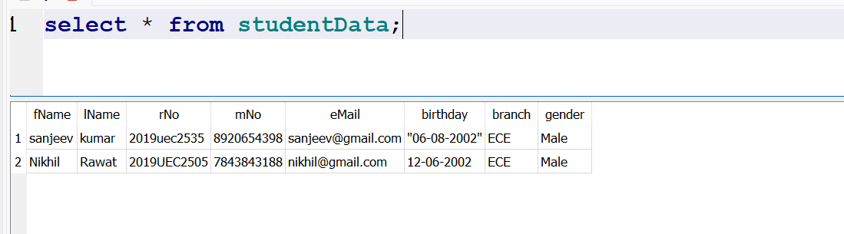

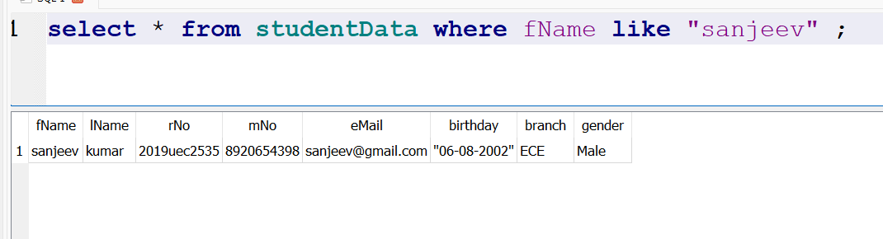

Experiment 8
Aim: Create a web site using any front end and back end web technology tool.
Solution:
Client Code:
import logo from "./logo.svg";
import "./App.css";
import axios from "axios";
import { useState, useEffect } from "react";
function App() {
const [showStudentData, setShowStudentData] = useState(false);
const [studentData, setStudentData] = useState();
useEffect(() => {
if (!showStudentData) return;
axios
.get("http://localhost:5000/")
.then((res) => {
console.log("student data :", res.data);
setStudentData(res.data);
})
.catch(() => alert("Server error!"));
}, [showStudentData]);
async function submitForm(formData) {
console.log("formData :", formData);
await axios({
method: "post",
url: "http://localhost:5000/",
data: {
formData: formData,
},
})
.then((res) => {
console.log("result :", res.data);
if (res.data) alert("Data saved successfully");
else alert("Error !!!");
})
.catch(() => alert("Server Error!!!"));
}
function validateForm(e) {
// e.preventDefault();
var fName = document.forms["myForm"]["fName"].value;
var lName = document.forms["myForm"]["lName"].value;
var rNo = document.forms["myForm"]["rNo"].value;
var mNo = document.forms["myForm"]["mNo"].value;
var eMail = document.forms["myForm"]["eMail"].value;
var birthday = document.forms["myForm"]["birthday"].value;
var branch = document.forms["myForm"]["branch"].value;
var gender = document.forms["myForm"]["flexRadioDefault"].value;
var description = document.forms["myForm"]["description"].value;

let formData = {
fName,
lName,
rNo,
mNo,
eMail,
birthday,
branch,
gender,
description,
};

console.log("fname :", fName);
console.log("lName :", lName);
console.log("rNo :", rNo);
console.log("mNo :", mNo);
console.log("eMail :", eMail);
console.log("birthday :", birthday);
console.log("branch :", branch);
console.log("gender :", gender);
console.log("description :", description);

if (fName.length == 0) alert("First name can not be empty");
else if (lName.length == 0) alert("Last name can not be empty");
else if (rNo.length != 11) alert("Enter valid roll number");
else if (mNo.length != 10) alert("Enter valid 10 digit mobile number");
else if (eMail.search("@") == -1 && eMail.length == 0)
alert("Enter valid email");
else if (branch.length == 0) alert("Select branch");
else if (birthday.length == 0) alert("Enter DOB");
else {
submitForm(formData);
}
return true;
}

return (
<div className="App">
<div>
<nav className="navbar navbar-expand-lg navbar-dark bg-primary">
<a className="navbar-brand" href="#">
Class App
</a>
<button
className="navbar-toggler"
type="button"
data-toggle="collapse"
data-target="#navbarNav"
aria-controls="navbarNav"
aria-expanded="false"
aria-label="Toggle navigation"
>
<span className="navbar-toggler-icon" />
</button>
<div className="collapse navbar-collapse" id="navbarNav">
<ul className="navbar-nav">
<li className="nav-item">
<a
className="nav-link"
href="#"
onClick={() => setShowStudentData(false)}
>
Student Detail Form
</a>
</li>
<li className="nav-item">
<a
className="nav-link"
href="#"
onClick={() => setShowStudentData(true)}
>
Student Data
</a>
</li>
</ul>
</div>
</nav>
{showStudentData ? (
<div id="studentDataPage">
<h1 className="center"> Student Data</h1>
<div className="container dataPage">
<div className="row head">
<div className="col-3">
<h3>Name</h3>
</div>
<div className="col-3">
<h3>Roll No</h3>
</div>

<div className="col-2">
<h3>Branch</h3>
</div>
<div className="col-2">
<h3>Mobile No</h3>
</div>
<div className="col-2">
<h3>Email</h3>
</div>
</div>

{studentData &&
studentData.map((val) => (
<div className="row">
<div className="col-3">
<h3>{val.fName + " " + val.lName}</h3>
</div>
<div className="col-3">
<h3>{val.rNo}</h3>
</div>
<div className="col-2">
<h3>{val.branch}</h3>
</div>
<div className="col-2">
<h3>{val.mNo}</h3>
</div>
<div className="col-2">
<h3>{val.eMail}</h3>
</div>
</div>
))}
</div>
</div>
) : (
<div>
<section id="about" className="about">
<div className="container">
<div className="row">
<div className="col-lg-12">
<h1 id="addPage" className="text-center">
Student Detail Form
</h1>
</div>
</div>
</div>
</section>
<section id="formSection" className="formSection">
<form name="myForm" onSubmit={validateForm}>
<div className="container">
<div className="row">
<label className="col-4" htmlFor="fName">
First Name
</label>
<input
className="col-4"
type="text"
id="fName"
name="fName"
/>
</div>
<div className="row">
<label className="col-4" htmlFor="lName">
Last Name
</label>
<input
className="col-4"
type="text"
id="lName"
name="lName"
/>
</div>
<div className="row">
<label className="col-4" htmlFor="rNo">
Roll Number
</label>
<input className="col-4" type="text" id="rNo" name="rNo" />
</div>
<div className="row">
<label className="col-4" htmlFor="mNo">
Mobile Number
</label>
<input className="col-4" type="text" id="mNo" name="mNo" />
</div>
<div className="row">
<label className="col-4" htmlFor="eMail">
Email
</label>
<input
className="col-4"
type="text"
id="eMail"
name="eMail"
/>
</div>
<div className="row">
<label className="col-4" htmlFor="branch">
Branch
</label>
<select
name="branch"
className="form-select"
aria-label="Default select example"
>
<option value selected>
Choose...
</option>
<option value="COE">COE</option>
<option value="IT">IT</option>
<option value="ECE">ECE</option>
<option value="ME">ME</option>
</select>
</div>
<div className="row">
<label className="col-4" htmlFor="gender">
Gender
</label>
<div className="form-check col-2">
<input
className="form-check-input"
type="radio"
name="flexRadioDefault"
id="flexRadioDefault1"
defaultValue="MALE"
defaultChecked
/>
<label
className="form-check-label"
htmlFor="flexRadioDefault1"
>
Male
</label>
</div>
<div className="form-check col-2">
<input
className="form-check-input"
type="radio"
name="flexRadioDefault"
id="flexRadioDefault2"
defaultValue="FEMALE"
/>
<label
className="form-check-label"
htmlFor="flexRadioDefault2"
>
Female
</label>
</div>
</div>
<div className="row">
<label className="col-4" htmlFor="birthday">
DOB
</label>
<br />
<input
className="col-4"
type="date"
id="birthday"
name="birthday"
/>
<br />
<br />
</div>

<div className="row">
<label className="col-4" htmlFor="description">
Description
</label>
<textarea
className="col-4"
name="description"
id="description"
defaultValue={""}
/>
</div>

<input type="submit" defaultValue="Submit" />
</div>
</form>
</section>
</div>
)}
</div>
</div>
);
}

export default App;

Server code:
const express = require("express");
const { MongoClient } = require("mongodb");

const app = express();
const port = 5000;
const cors = require("cors");
app.use(cors());
app.use(express.json());

const mongodb_url = "mongodb://localhost:27017";
const client = new MongoClient(mongodb_url);

// Database Name
const dbName = "webTech";

app.get("/", async (req, res) => {
const db = client.db(dbName);
const collection = db.collection("documents");
const data = await collection.find({}).toArray();
console.log(" result :", data);
res.send(data);
});
app.post("/", async (req, res) => {
let formData = req.body.formData;
console.log("received data :", formData);
const db = client.db(dbName);
const collection = db.collection("documents");
const insertResult = await collection.insertOne(formData);
console.log("insert result :", insertResult);
res.send(insertResult.acknowledged);
});

app.listen(port, async () => {
console.log(`Example app listening on port ${port}`);

await client.connect();
console.log("Connected successfully to server");
});

Result:

Result:

